INSTITUTO EDUCACIONAL JUAN XXIII
Valencia, February, ______________________
Name: _________________________________
2nd grade: _________

STUDY GUIDE

- Write the type of story that belongs to the picture/ Escribe el tipo de historia que corresponde con la imagen.

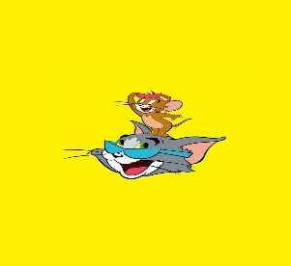_______________________
______________________
___________________

_________________________

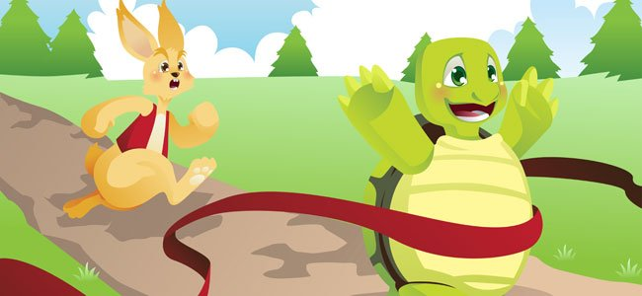 _______________________
2.-Answer the questions/Contesta las preguntas:
Example:
-What is your favorite story?
It`s Comedy.

a.-Do you like horror stories?

b.-What do you prefer romance or comedy stories?

c.-Does your mother like romance stories?

3.-Complete the following dialogue / Completa el siguiente dialogo:

Situation: The teacher takes her students to a library so they can read their favorite stories. (La maestra lleva a los alumnos a la biblioteca para que así puedan leer sus historias favoritas).

Teacher: Come on guys, choose your favorite stories!!
Rose: Ann, what is your favorite_________?
Ann: It´ s______________ because they are funny.
Teacher: Rose, do you like _____________stories?
Rose: No, I don`t like_______________ because they are scary.
And you teacher what is your favorite _________?
Teacher: I like ____________stories because they are very cute.
Okey!! Everybody let's _________ and enjoy this wonderful moment.

Story (2)/ Horror (2)/ Read/ Romance/ Comedy

