 Instituto Educacional Juan XXIII

Valencia, ___________, February, ___________

Name: _________________________________

4th Grade “______”

STUDY GUIDE

**Unit 3**

**How do we Communicate**

1. **Write the words of the pictures.**

**Ex.** *TV*

  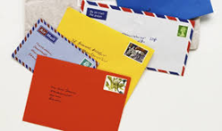

**2**

**3**

**1**

**  **

**6**

**5**

**4**

1. **__________________________ 4. ________________________**
2. **__________________________ 5. ________________________**
3. **__________________________ 6. __________ TV___________**
4. **Unscramble the sentences.**

**Ex.** *We / listen / the / to / always / radio*

**We always listen to the radio.**

1. **news. / are / latest / These / the ____________________________________________________**
2. **favorite / your / Who / youtuber? / is ______________________________________________________________________**
3. **from / received / I / letter / cousin. / my / a ____________________________________________________**
4. **loves / She / read / books. / to ____________________________________________________**
5. **computer / buy / I / new / a / will / office. / my / for**

**____________________________________________________**

1. **series. / watching / He / new / a / is / TV**

**____________________________________________________**

1. **Complete the crosswords with the correct words.**

1



8

7

6

5

4

3

2

**  **

3

2

1

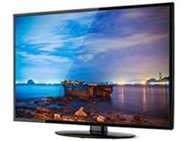  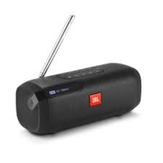

6

5

4

8

7

** **

**REMEMBER TO TURN IN THIS GUIDE/ Recuerda entregar esta guía cuando durante la semana de la evaluación formativa (feb. 3rd to 7th).**

**THIS GUIDE IS GOING TO BE EVALUATED!**

