Instituto Educacional Juan XXIII
Valencia, ___________, February, ___________
Name: _________________________________
3rd grade “______”

STUDY GUIDE
Unit 3
- Write the words of the pictures.
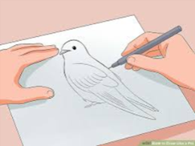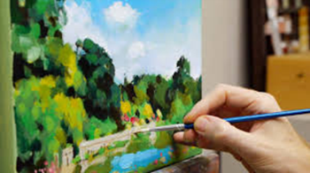
3
1
2

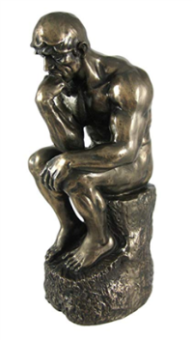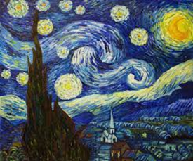
4
5

- __________________________ 4. ________________________
- ___________To draw_______ 5. _________________________
- __________________________

- Unscramble the sentences.
Ex. likes / the sky. / to paint / She

- going / teather. / to / Robert / the / is ____________________________________________________

- beautifully. / Her / is / painting ______________________________________________________________________

- Mary / to / draw. / loves ____________________________________________________

- sculpture / is / That / heavy. ____________________________________________________

- Complete the Role Play with the correct words.

Ex. Guide: __Hello__! Welcome to the museum.

Visitor 1: Hello! _______________________
Visitor 2: Can you please show us the __________________________?
Guide: _________! This way.
Visitor 3: WOW! There are a lot of _________________________.
Visitor 1: Yes! They are __________________________.
Visitor 2: They are _______________________.
Visitor 3: I don´t ______________ paintings, I prefer _________________________.
Visitor 1 and 2: Art is ________________________, We _________________ art!
Guide: Thank you for your _____________________!

Paintings / big / interesting / love / beautiful
Visit / painting room / Yes / thank you / like / sculptures

THIS GUIDE IS GOING TO BE EVALUATED!

