Valencia, ___________, February, ___________
Name: _________________________________
1st grade _____

STUDY GUIDE UNIT # 3
1.-Write the name of each element that belongs to nature/ Escribe el nombre de cada element acuerdo al tipo de paisaje:

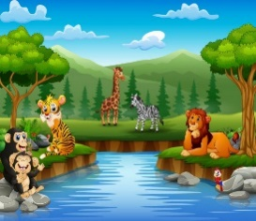
________________________

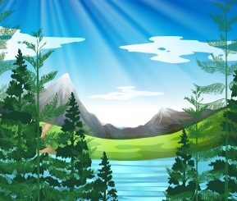 ___________________________
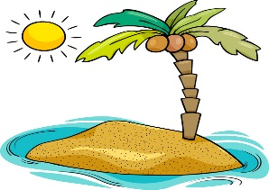 __________________________

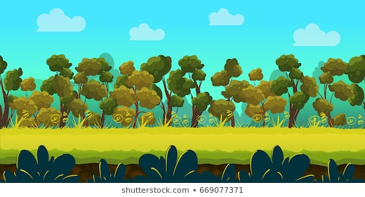 __________________________

2.-Complete with THERE IS or THERE ARE/ Completa con There is o There are:

a.-_________________________a big river in Venezuela.
b.-_______________________a lot of islands in Morrocoy.
c.-_________________________is a volcano in the island.
d.-__________________________two lakes in the forest.
e.-___________________________a lot of trees in the montain.

3.-Answer the Questions with YES THERE ARE, NO THERE AREN`T/YES THERE IS,NO THERE ISN`T / Contesta las preguntas con YES, THERE ARE/ NO, THERE AREN’T/ YES, THERE IS/ NO, THERE ISN’T.

a.-Is there a volcano in Hawaii?____________________________________________
b.-Are there many beaches in Venezuela?____________________________________
c.-Is there a big lake in Maracaibo?_________________________________________
d.-Is there snow in an Island?______________________________________________

